**HOME**

1) Make the size of the blue bar thicker

2) Increase the size of the logo and size of text. Bold the phone number and email address.

3) Change the order of the menu bar to read as follows:

Home; Services; About Us; Common Questions; Get a Quote (instead of contact us), Gallery

ADDITIONAL: When people hover their mouse over ‘Services’’ please have a drop down bar that lists in this order:

**Shower Installations**

**Shower and Acrylic Repairs**

**EnduroShield**

**Bathroom Renovations**

**Insurance Jobs**

Note: Remove Testimonials

4) Change the colour of the panels to grey with a grey outline (instead of blue with a yellow outline). Please also change ‘get started today’ (and make this larger)’in grey with a grey outline. Please remove ‘view services

5) Increase font size of ‘Shower Power’

6) Increase font size of ‘Northlands Leading Certified Shower Installers and Bathroom Specialists’

7) Increase font size of Upgrade your bathroom with confidence, done right the first time’.

//////////////////////////////////////////////////////////////////////////////////////////////////////////////

**SERVICES**

Please reduce the size of each photograph (to match the size with the text).

This text should be amended to read as follows – please note some of the text has stayed the same:

**Shower Installations**

Your shower is one of the most important features in your bathroom - and you deserve one that looks fantastic, functions perfectly, and stands the test of time.

If your existing shower is cracked, worn, leaking, or simply beyond saving, we can supply and install a modern replacement to suit your space and style. Speak

From sleek frameless glass showers to more traditional designs, we install all shower types with precision and care — taking the hassle out of the entire process.

Thanks to our strong relationships with leading shower and glass manufacturers, there’s virtually nothing we can’t do with a shower. We offer a wide range of hardware finishes and colour options to suit every style.

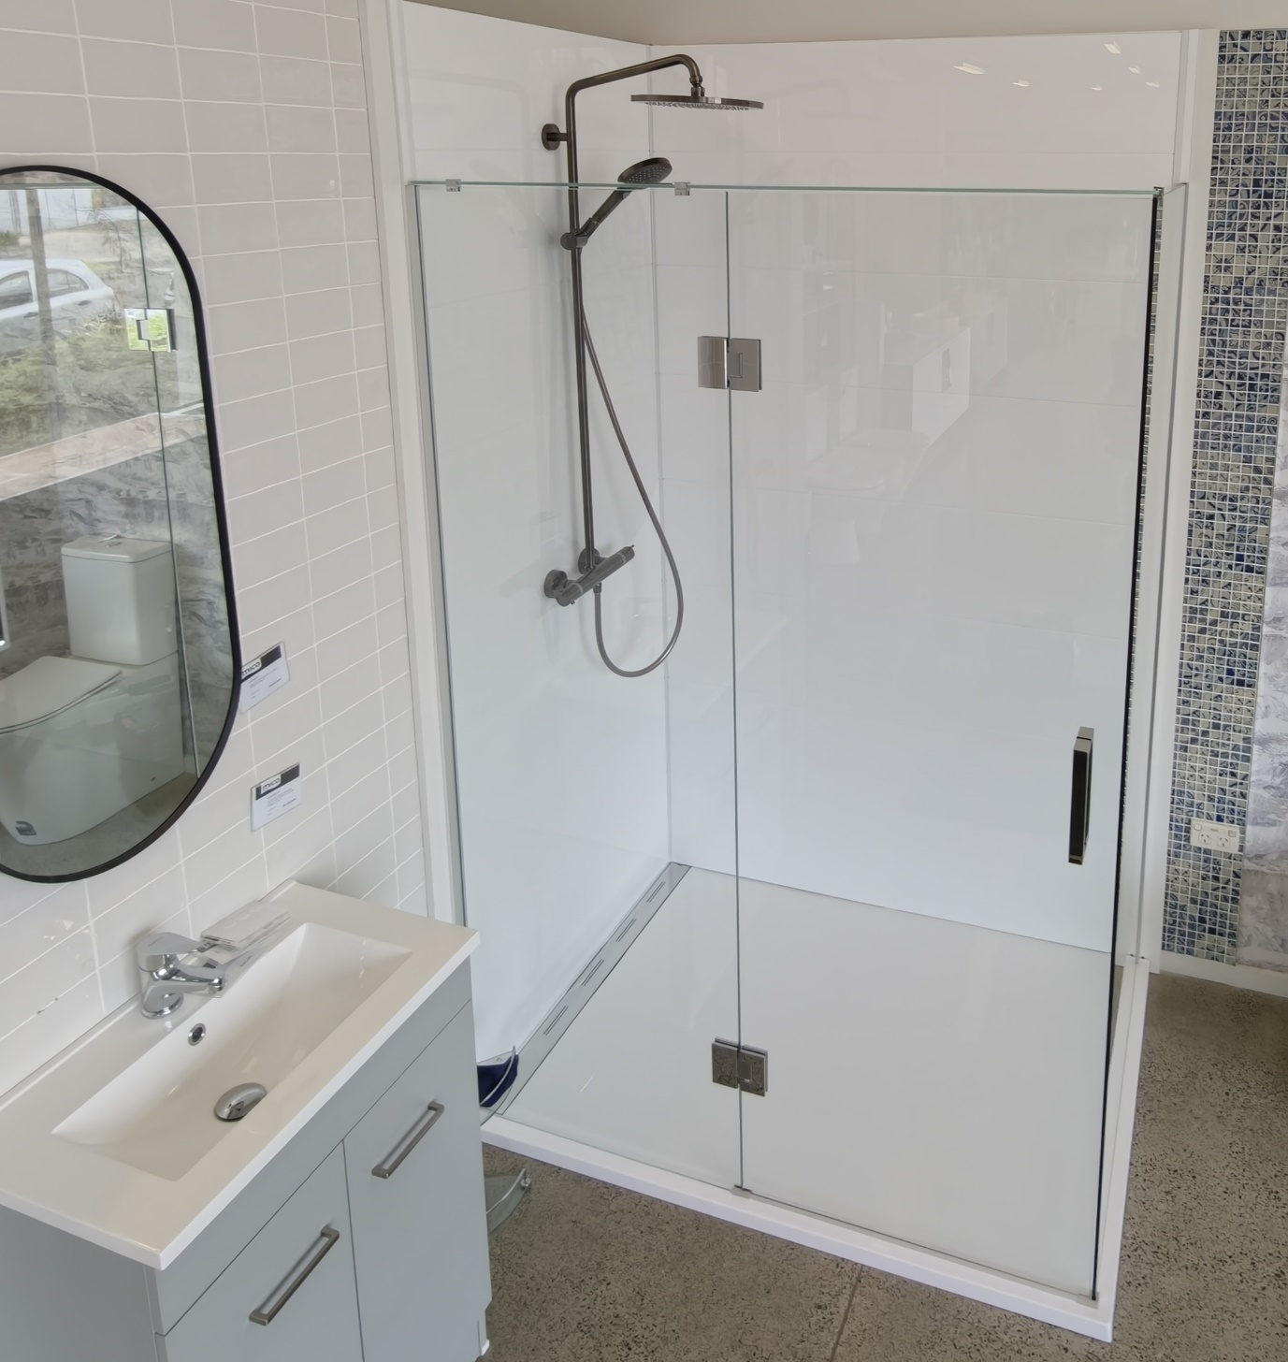

**Shower and Acrylic Repairs**

From minor fixes to major repairs, we keep your shower safe, watertight, and working properly.

At the first sign of leaks or cracks, it’s best to act quickly — delays often lead to far more expensive repairs behind walls or under floors.

Our services include:

* Acrylic repairs to shower liners, vanities, bath tubs and shower trays
* Shower door replacement (hinged, sliding, pivot or curved)
* Complete shower rebuilds
* Water damage repairs caused by leaking showers

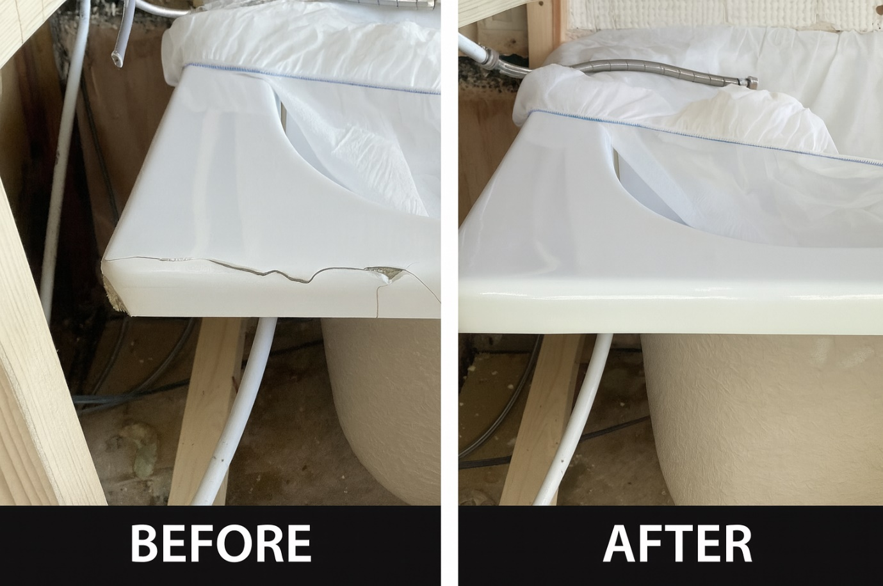

**EnduroShield**

EnduroShield’s advanced hydrophobic coating creates an invisible protective barrier that repels water, soap scum, and grime, keeping glass cleaner for longer and making maintenance effortless.

We supply and apply EnduroShield to restore and protect your shower glass and other glass surfaces, ideal for:

* Shower glass
* Balustrades
* Pool fencing
* Windows
* Solar panels
* Boats & more

Spend less time cleaning and enjoy sparkling glass year-round.

Learn more about EnduroShield - https://www.youtube.com/watch?v=uN9gjAambqA

(Please create a quick link to this website address).

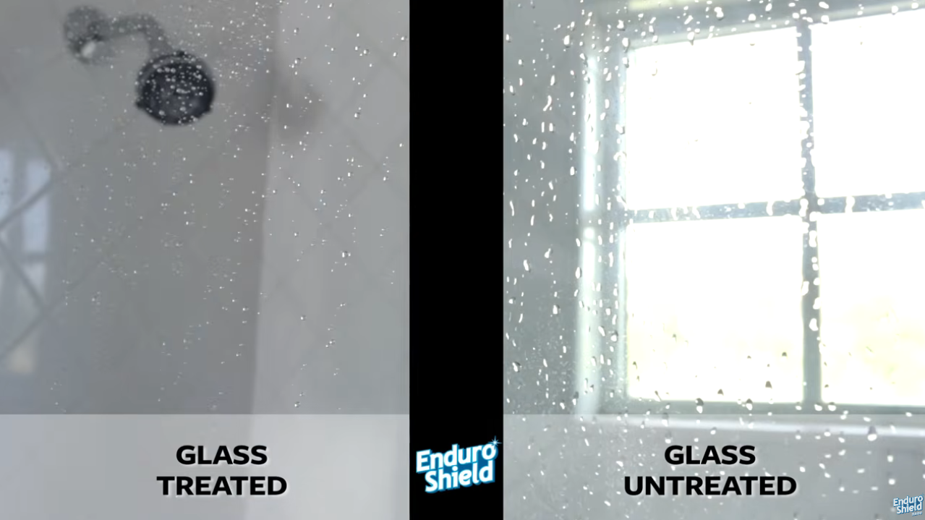

**Bathroom Renovations**

We offer complete bathroom renovation services to improve both appearance and functionality.

We also specialise in cost-effective partial upgrades, working only on the areas that need attention — such as:

* Shower replacements
* Damaged flooring
* Walls
* Vanitity installation
* Shower liner and bath tub installations
* Waterproofing repairs

This flexible approach allows you to achieve great results without replacing the entire bathroom.

**Insurance Jobs**

Think your shower damage might be covered by insurance? It often is — and we can help.

We work directly with all insurance providers or via referral. Our service includes:

* Site inspections
* Written damage reports
* Insurance assessments
* Project management of repairs or replacements
* Organising sub-trades
* Product sourcing
* Insurance communication

We handle the entire process for you — making your repair simple and stress-free.

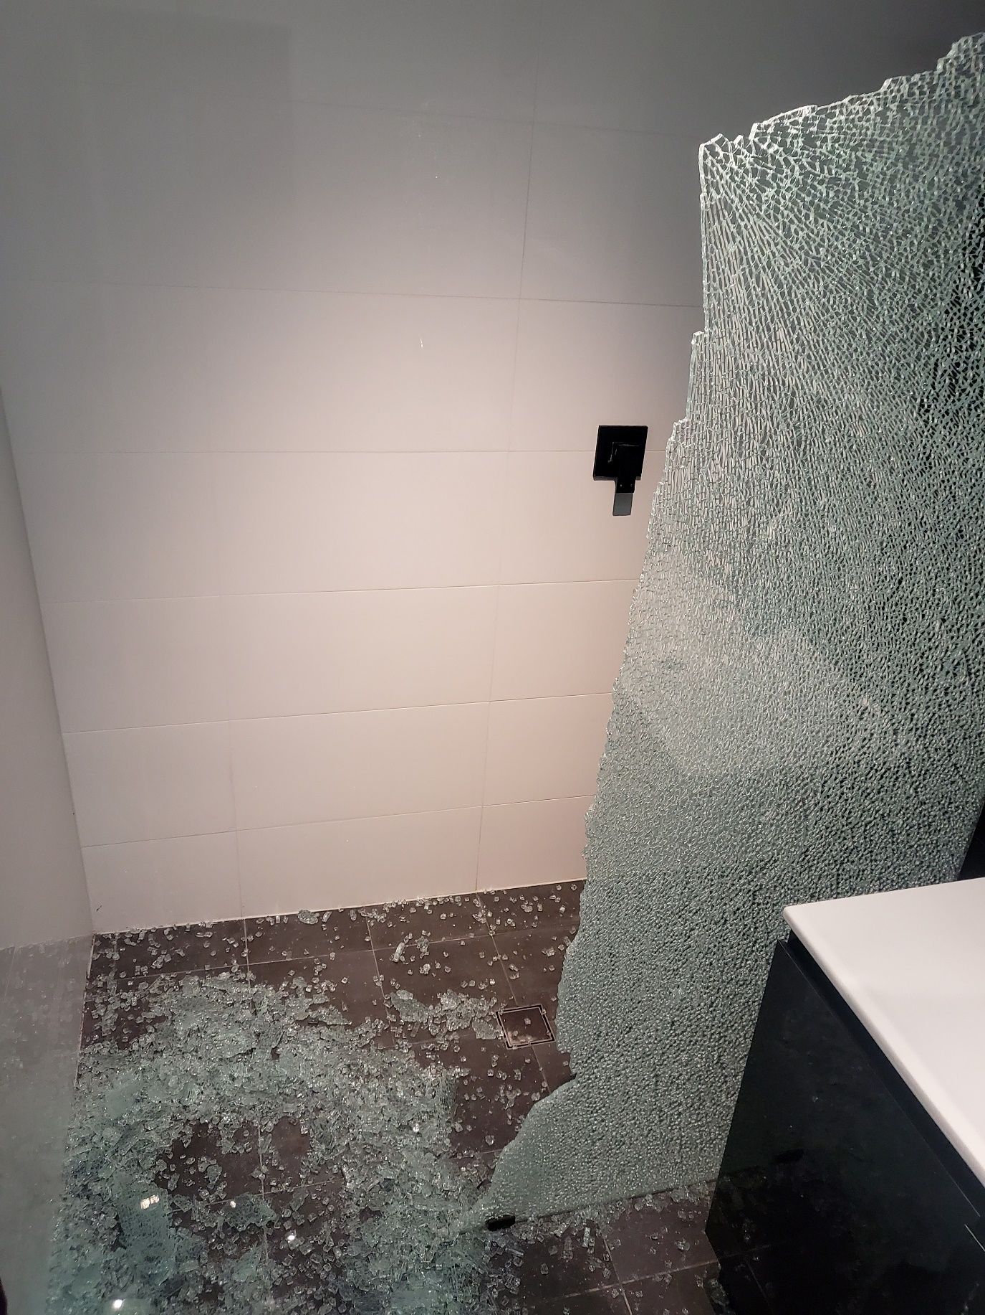

Notes

-Move ‘why choose us’’ under ‘Contact Us’’. Pleaser remove the icons from this.

-Our Trusted Partners -Please put this in colour without needing to hover your mouse over it

-Put ‘request a quote’ in blue (should look the same as ‘get started today’’

**ABOUT US**

The text looks great.

The below photograph



‘’Get started today’ all in blue (without the yellow border)

COMMON QUESTIONS

This looks perfect. However, please add another heading as following:

**How do I prepare the bathroom for shower installation?**  
If you wish to save some money and prepare the bathroom before we come, here’s how!

Your bathroom should have a solid timber framing where the shower channels will sit (around 100mm in from the tray edge), with extra support from any shelves or shower seats. Wals need to be straight, plumb and unfished, and the floor must be level and clear around the waste outlet. For alcove showers, the back wall should be 5-7mm wider than the liner for the best fit.

Not ready or unsure? We are happy to complete the preparation work for you at an additional cost – just let us know and we will take care of it!

**GET IN TOUCH**

Please include an additional line with a drop down bar:

What are you enquiring about? (Drop down options:)

New Shower Install; Shower Repairs; Acrylic Repairs; Glass Restoration; EnduroShield; Bathroom Renovation; General Enquiry